General Knowledge
TIP: Provide general information and code snippets to demonstrate how the described scenario can be implemented.
I have started using your jQuery library but it seems that I couldn’t fully understand how it works. I’m trying to display the content of my page according to the clicked menu item, but the selection of the DOM elements is failing. For example, this function is supposed to hide all of the content but it doesn’t:
function hideAllContent() {
$('home-page-content').hide();
$('courses-page-content').hide();
$('about-page-content').hide();
$('contact-page-content').hide();
}
What am I missing here?

Solution

Hello John,
I think you are missing to add the class or the id selectors when selecting elements.
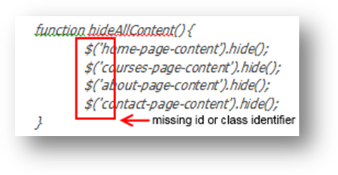
Below is the code snippet with the added missing selectors. Please give it a try and tell me if it is working. You could check the documentation of jQuery on this link.
https://api.jquery.com/id-selector/
Just double click on the code if you want to copy it.
Best Regards
Martin Veshev

